**ANGULAR 8**

What is angular?

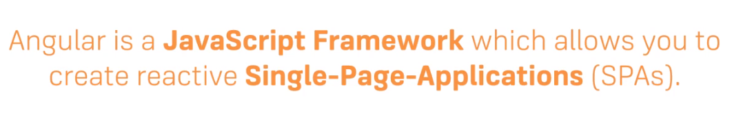

**1.What is SPA?**

The single page application (SPA) basically a web application whose all functionalities are framed on a single page where user can navigate different sections of the page by clicking on its dedicated links or buttons without loading because all the HTML, CSS and JS files are rendered on the same page. They give better user experience and It has only one HTML file and bunch of java script and CSS codes

**2. Angular versions:**

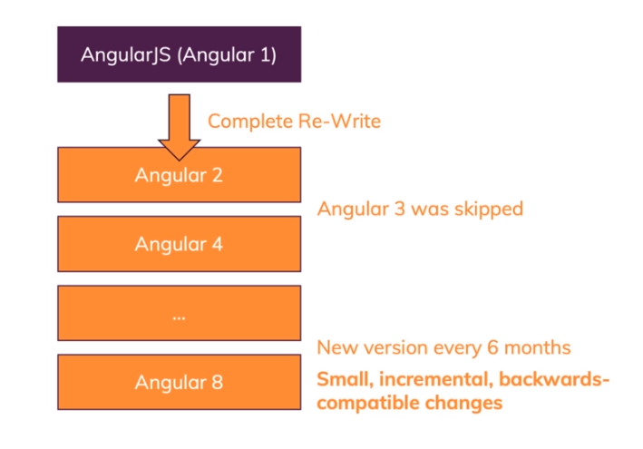

* Angularjs was introduced in 2010.It is also called as Angular1
* Angular2 is complete rewritten framework and it is introduced in 2016.
* Google introduces a new version for every 6 months. Now we are using Angular8.

**Angular course structure:**

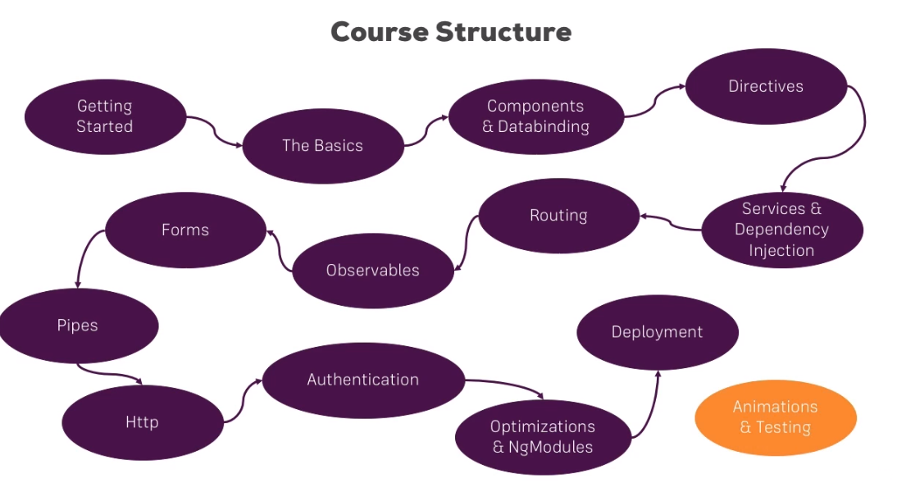

**What is Typescript?**

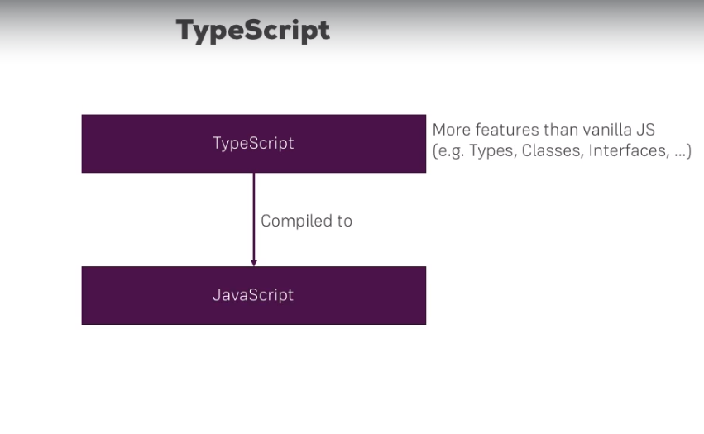

* Typescript is a strongly typed, object oriented language.
* It is a superset of JavaScript.
* Typescript always point out the compilation errors at the time of development only

**How to install angular8?**

Before to setup environment for Angular development using the Angular CLI tool, we must have installed Node.js on the system and npm package manager.

* Now we have to install typescript , for that open node.js command prompt and run the following command

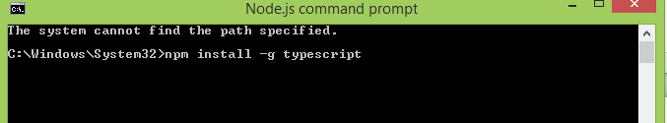

* After running the above command the following window will appear.

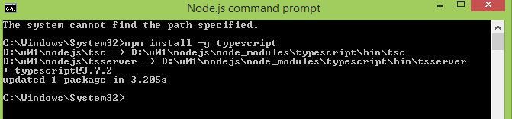

* Type script was successfully installed.
* Now we have install angular CLI (command line interface) , for that type below command in node.js command prompt.

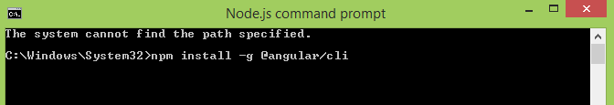

* After running above command the following window will appear.

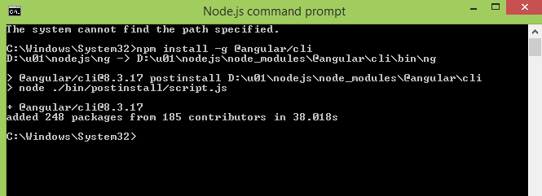

* Now we have to check whether angular is properly installed or not. For that run the below command .

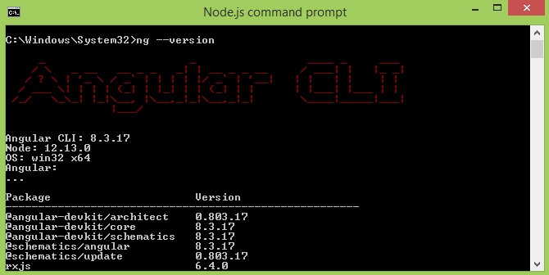

**How to create an angular project?**

* To create an angular project run the following command in command prompt.

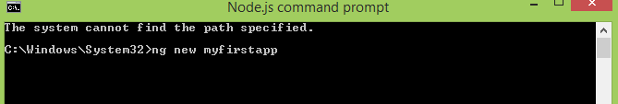

Here myfirstapp is a filename of newly created project.

* Now it will ask you to add angular routing to your project or not

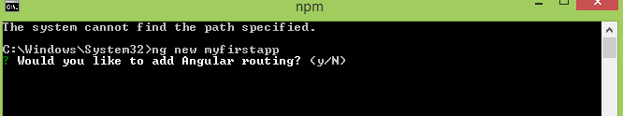

* Type y to select routing
* After that it will ask you to which type of style sheet would you like

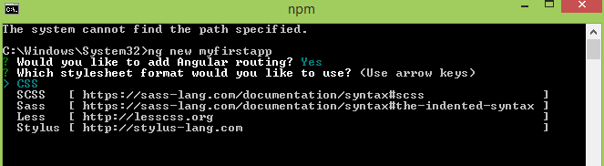

* Select css and press enter.
* Now observe the new project files are created.

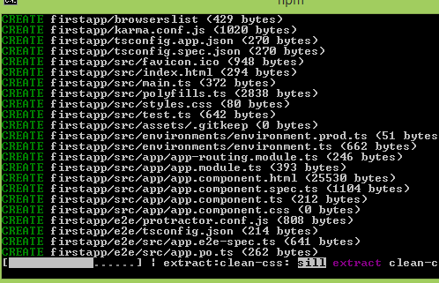

**How to run a angular project?**

* To run an angular project type the following command and run.

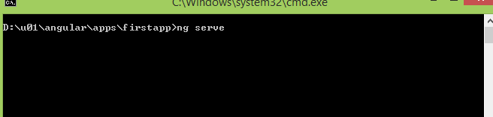

* Now observe what will happen. success fully compiled

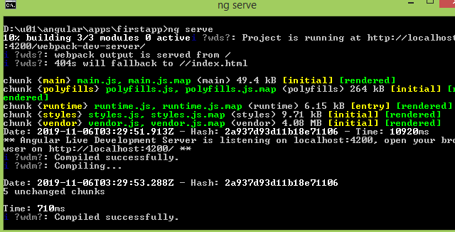

**008// video**

**What is package.json file contains?**

It contains libraries versioning information but not libraries.

**How to install bootstrap framework into angular?**

* First open the command prompt and run the below command

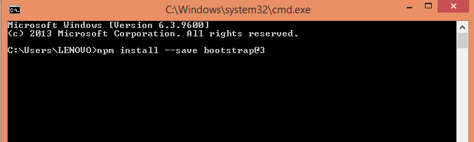

* Now it display the below window as 1 package is installed.

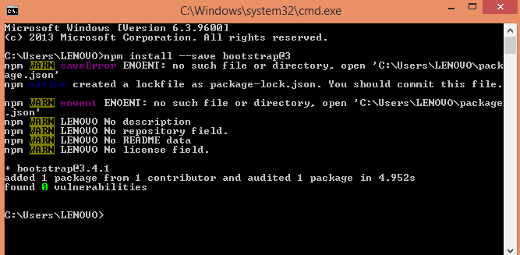

* For that open the bootstrap folder.
* Go to dist folder and open it. Now go to CSS folder and open it.
* Now copy the location of ‘bootstrap.min.css’ file.
* Now go to your project folder ( ex. Firstapp )
* Now open the angular.json file with the notepad++. It will display as below

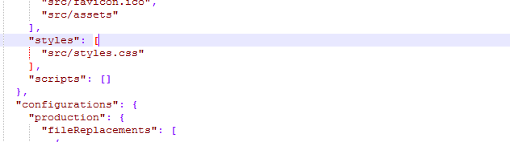

* Now paste the file location as below

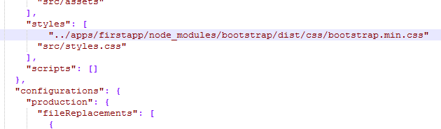

* Now save the file.

**How to check whether bootstrap is installed properly or not?**

* Now run the project as follows.

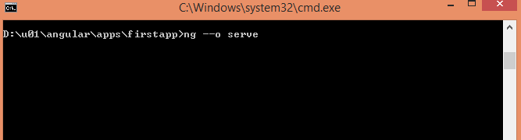

* It will compile the file and open the project in default web browser.
* Now right click on the app and go to inspect element.
* Now observe there is a additional style element is added.open the style tag you will get below as

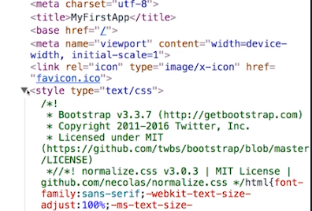

**How to install visual studio?**

* Open the downloaded file.
* Accepts terms and conditions and click next.

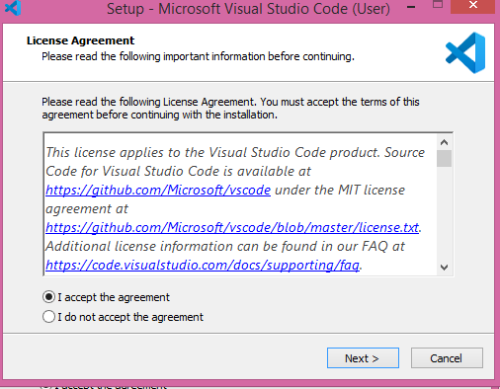

* Click on next

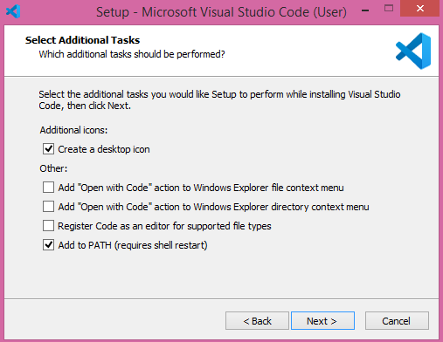

* Now click on install.

**15 How an angular app gets started and loaded?**

when we created any new project, the contents of the new file is always same or a default code. This is the original code in the app.compoment.html file.

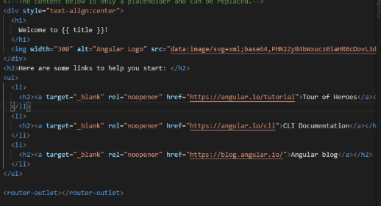

Let's remove all the code from the app.compoment.html file and write some basic HTML code.

Example:

|  |
| --- |
| <h3>This is first angular application and I'm in app component.<h3> |

Now run the project we get following output.

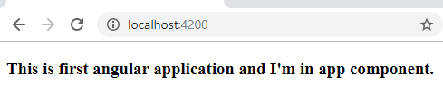

Here the above file is not served by the server. Index.html file is served by the server.

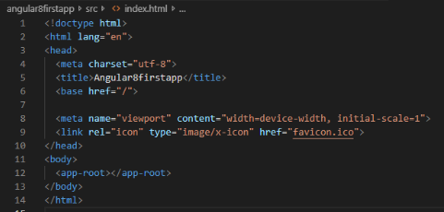

Here, you see "<app-root>" tag which is provided by the CLI. We can say that, whenever we create a project from CLI, by default, one component is created, i.e., "app component".

Now, see the "**app.component.ts**" file. It is a Typescript file. Here, you see the "selector" property.

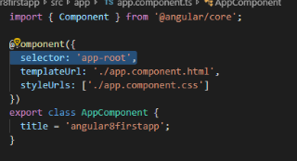

Now You can see that the selector property contains the string (app-root) as index.html file. This information is required forthe Angular to place this part into an index.html file with the template of the component. The template of the component is "./app.component.html", so, Angular includes this part into the body of the index.html file.

Whenever ng-serve builds the application, it creates "bundles" and automatically adds these to index.html file at runtime. So, from these bundles, the first code has to be executed from "main.ts" file, that is "main.ts" file is the main file from where the execution of an Angular application starts.

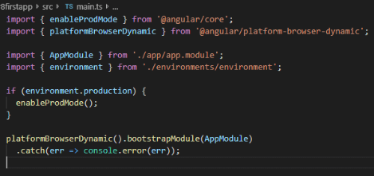

Here, the bootstrap method starts the Angular application. It refers to AppModule, which looks into the app folders. You can see in the "app.module" file that a bootstrap array which is basically a list of all the components analyzes the index.html file.

**App.module.ts file:**

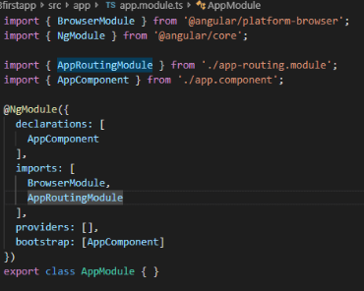

Finally the steps involved in the loading of angular app are as follows:

main.ts  >>

 app.module.ts  >>

 app.component.ts  >>

index.html  >>

app.component.html

**16.Components are important:**

Components are the building blocks of Angular. The whole application is built by using different components. They make your complex application into reusable parts.

**17.How to create a new component?**

Open visual studio code >> Go to your project source folder>> Expand the app directory and create a new directory named "server".

Now, create the component within server directory. Right click on the server directory and create a new file named as "server.component.ts". It is the newly created component.

**18. Creating components with CLI :**

Now run the following commands in the visual studio code terminal or command prompt.

|  |
| --- |
| ng generate component component_name  Or  ng g c component_name |

**018 Understanding the role of AppModule and Component Declaration:**

**019 Using custom components**

Create in a custom component and add the component selector into another component to html file

**020 create a component with the CLI & nesting components**

To using create components: ng g c component name.

Created the nested components create, delete and edit components to view employee folder.

**021 Working with component templates.**

It is not recommended and 0this type used for single inline html code .

022 **Working with component styles.**

Mostly recommended external libraries. We are using small code using this type

**023 Fully understanding the component selector.**

It will works on three ways. They are

1. Element selector. (<>).
2. Attribute selector. [ ]
3. Class selector. (.)

In app.component.ts file while using selector in square brackets.

We can write html file by using bootstrap.

**024 Inline HTML and inline CSS component assignment.**

**025 What is data binding?**

We could basically translate data binding with communication. Communication between your Typescript code of your component, your business logic and the template, we want to output data from our Typescript code in the HTML code in the template. We can use **string interpolation** for this.

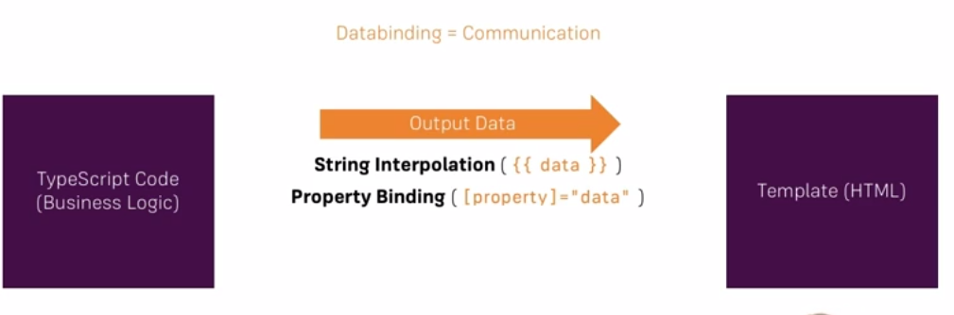

If we click a button, we maybe want to trigger something in our Typescript code, so now we need the other direction and we can get this other direction and we can react to user events with **event binding** for example a click event to execute some code whenever it occurs

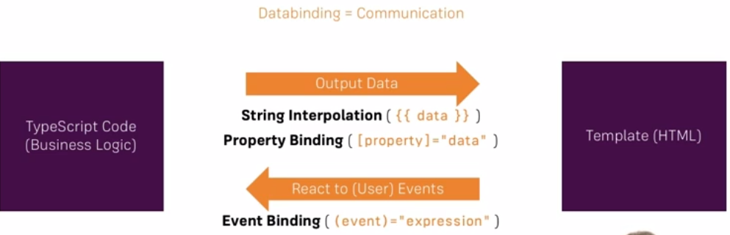

We also have one additional form of data binding where we combine both directions, **two-way data binding**, where we are able to react events and output something at the same time



**026 String interpolation:**

String interpolation is used to display dynamic data on HTML template. It facilitates you to make changes on component.ts file and fetch data from there to HTML template (component.html file).

**EXAMPLE:**

**Component.ts file:**

|  |
| --- |
| import {Component} from '@angular/core';  @Component(  {selector: 'app-server',  templateUrl: 'server.component.html'})  export class ServerComponent {  serverID: number = 10;  serverStatus: string = 'Online';  } |

**Component.html file:**

|  |
| --- |
| **<p>**Server with ID **{{serverID}} is {{serverStatus}}**. **</p>** |

**Output:**

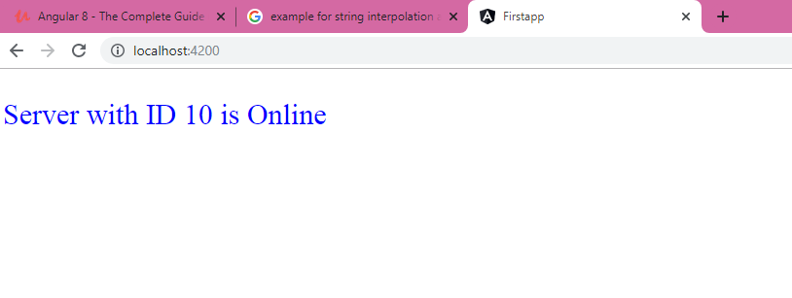

27.**Property binding:**

Property binding is used to pass data from the component.ts and setting the value of the given element in the component.html. Property binding is an example of one-way data binding where the data is transferred from the business logic to the template

**Component.ts file:**

|  |
| --- |
| import { Component, OnInit } from '@angular/core';  @Component({  selector: 'app-kishan',  templateUrl: './kishan.component.html',  styleUrls: ['./kishan.component.css']  })  export class kishanComponent implements OnInit {  allowNewServer = false;  constructor() {  setTimeout(() =>{  this.allowNewServer = true;  }, 5000);  }  ngOnInit() {  }  **}** |

**Component.html:**

|  |
| --- |
| <p>kishanserver is also working fine. </p>  <button class="btn"  **[disabled]="allowNewS erver**">Add Server</button> |

**Output:**

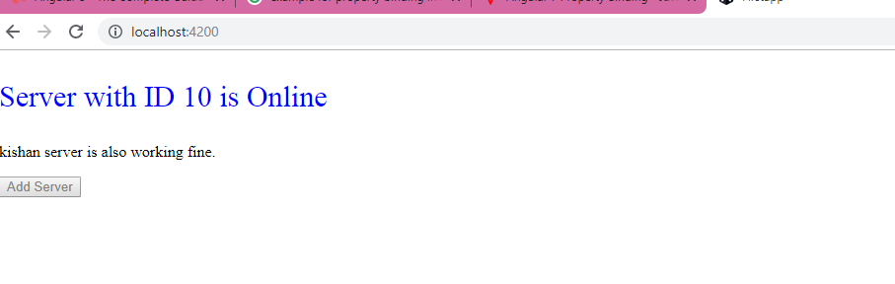

**String interpolation VS Property binding:**

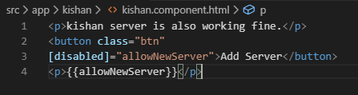

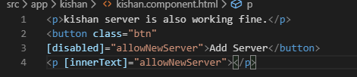

In the both cases output is same. So to display something directly use string interpolation.

To change the property value dynamically use property binding.

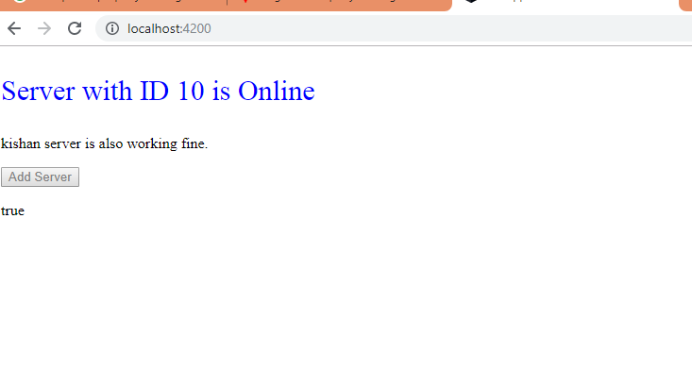

**29.Event binding:**

Angular facilitates us to bind the events along with the methods.

**Example:**

**Component.ts file:**

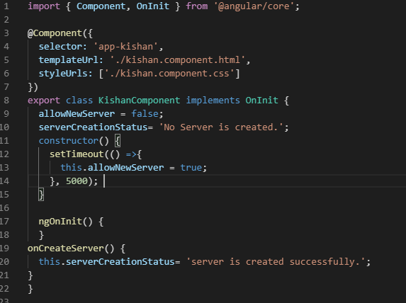

**Component.html file:**

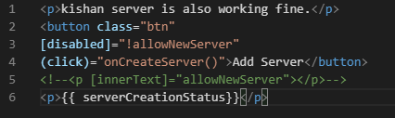

**Output:**

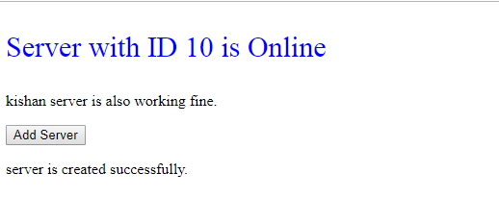

**31. Passing and using Data With event Binding**

**Html code:**

h1>Left Template</h1>

<label>feedback</label>

<input type="text" class="form-control" (input)="onFeedback($event)">

<p>{{feedback}}</p>

**Typescript code:**

import { Component } from '@angular/core';

@Component({

selector :'app-left',

templateUrl:'./app.left.html',

styleUrls: ['./app.left.css']

})

export class AppLeft{

title = 'AppLeft';

feedback ='';

onFeedback(event: Event){

console.log(event);

this.feedback =(<HTMLInputElement>event.target).value;

}

}

**Output:**

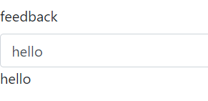

**32. 2-Way binding:**

In two-way data binding, automatic synchronization of data happens between the Model(typescript) and the View(HTML). Whenever you make changes in the Model, it will be reflected in the View and when you make changes in View, it will be reflected in Model.

Important: For Two-Way-Binding we need to enable the **ngModel** directive. This is done by adding the **FormsModule** to the**imports[]**  array in the **AppModule.**

**Example:**

**App.left.ts file:**

<label>description with two way binding</label>

<input type ="text" class="form-control" [(ngModel)]="description">

<p>{{description}}</p>

**App.left.html file:**

import { Component } from '@angular/core';

@Component({

selector :'app-left',

templateUrl:'./app.left.html',

styleUrls: ['./app.left.css']

})

export class AppLeft{

title = 'AppLeft';

feedback ='';

description = 'testdescription';

onFeedback(event: Event){

this.feedback =(<HTMLInputElement>event.target).value;

}

}

**Output:**

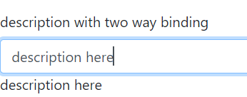

**36.What are directives?**



* Two types of directives are available.
* Those are

1. Directives with template (ex: components)
2. Directives without template

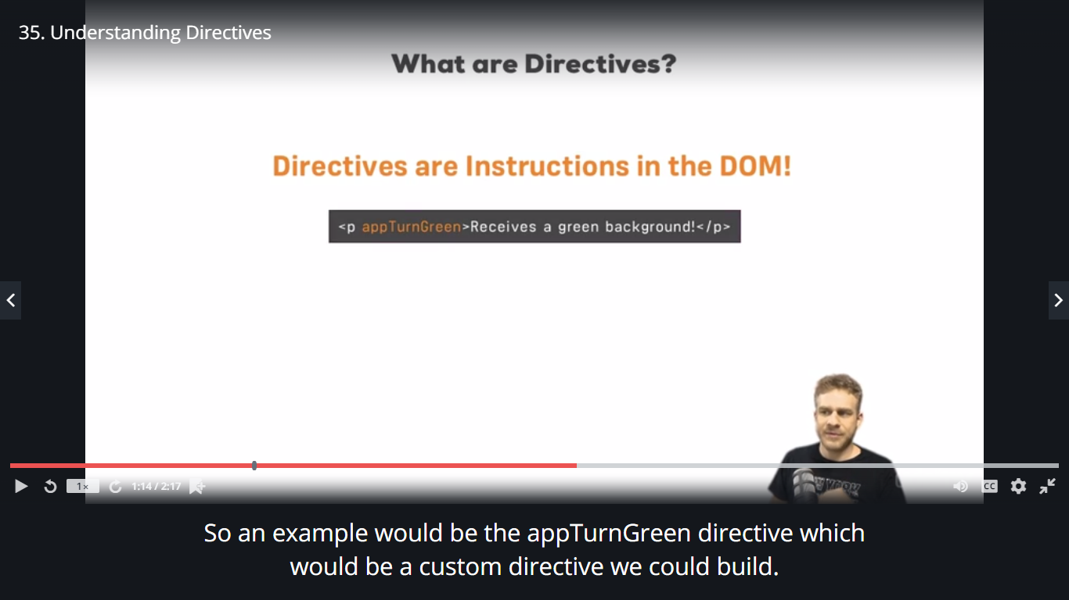

We typically add directives with an attribute selector on this paragraph, this directive might simply color the text green you could say. So Angular would

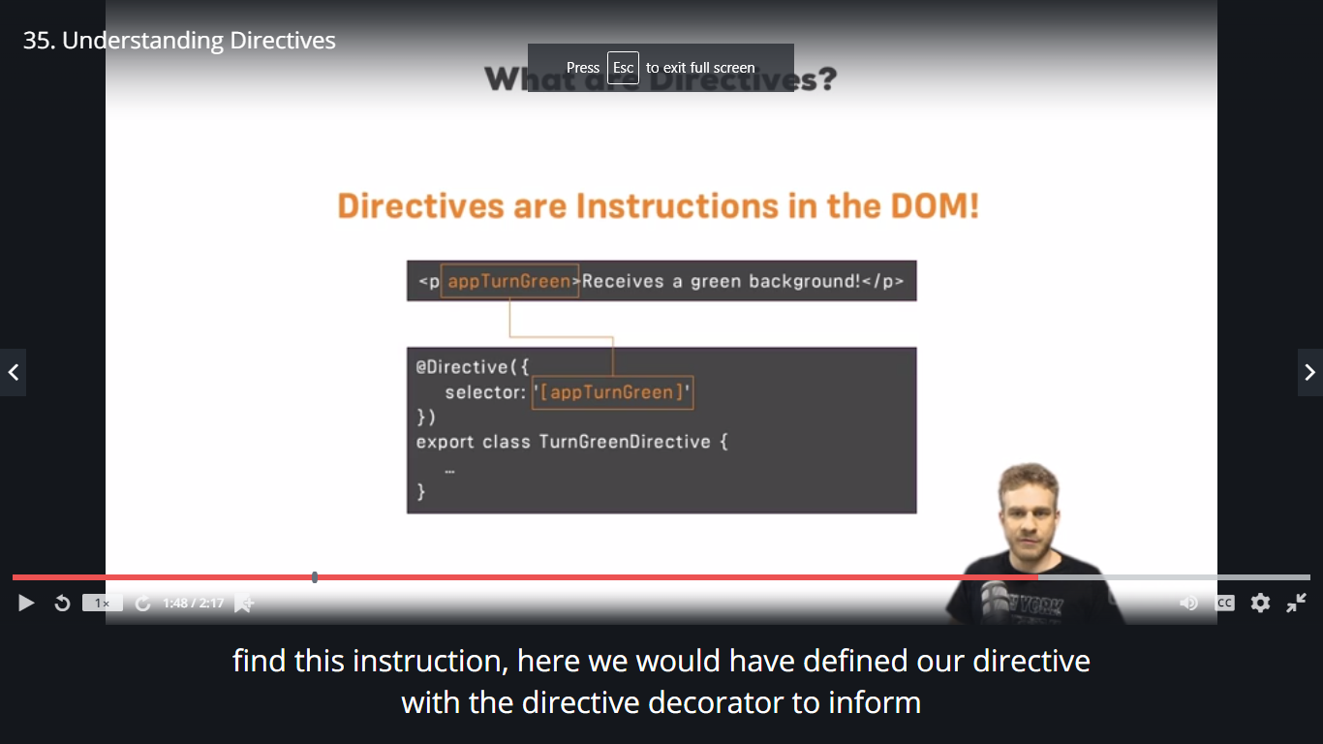

Angular that this class holds a directive and there, we might have the logic to turn this green.

**36**

**NGIF DIRECTIVE:**

* It works as if statement.
* Nglf is added by adding * . This star is important because nglf is a structural directive which means it changes structure of the DOM ,it either adds this elements or it doesn’t add it by passing true or false.

**App.right.html file:**

<h1>Right Template</h1>

<input type="number" class="form-control" [(ngModel)]="year">

<button (click)="checkLeapYear()">Check</button>

<p *ngIf="isLeapYear">{{message}}</p>

<p *ngIf="isNotLeapYear">{{message}}</p>

**App.right.ts file:**

import { Component } from '@angular/core';

@Component({

selector :'app-right',

templateUrl:'./app.right.html',

styleUrls: ['./app.right.css']

})

export class AppRight{

title = 'AppRight';

year : any;

isLeapYear= false;

isNotLeapYear=false;

message='';

checkLeapYear(){

if ((Number(this.year)%4)==0){

this.message = 'leap year';

this.isLeapYear = true;

console.log('leap year');

}

else{

this.message = ' not a leap year';

console.log('not a leap year');

this.isNotLeapYear= true;

}

}

}

**Output:**

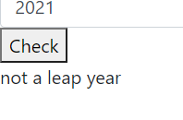

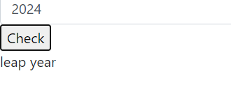

**38.Enhancing nglf with else statement:**

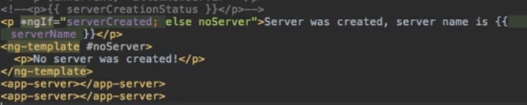

**39 ngStyle directive:**

If want to change the color, the background color of the component dynamically we will use ngstyle directive.



**40 ngClass directive:**

ngStyle allowed us to change the CSS style itself, ngClass allows us to dynamically add or remove CSS classes.`

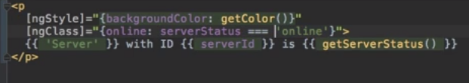

**41 ngFor directive:**

this directive is used to repeat a portion of HTML template once per each item from an iterable list.

Here we define a temporary variable for inside the loop with let, give it any name you like, like server for example and then of servers. Servers here is the property we defined in the Typescript file and this will now loop through all elements in this array and assign the individual element to this dynamic server

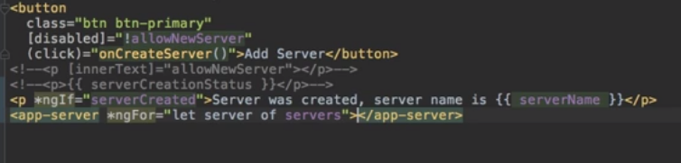

**63.Debugging:**

Using angular augury extension in chrome.

**Project:**

**Recipe book and shopping list app**

**Planning the app:**

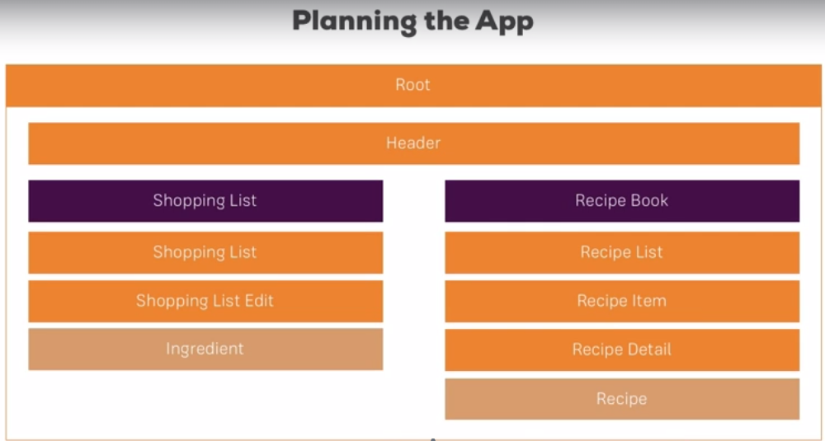

**Creating new components:**

Create the following components as follows.

1. Header

2. Recipes

(i) Recipe-list

* Recipe-item

(ii) Recipe-details

3.shopping-list

(i)shopping-list edit

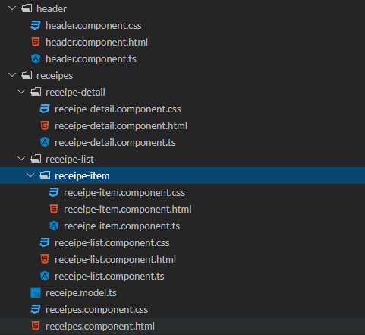

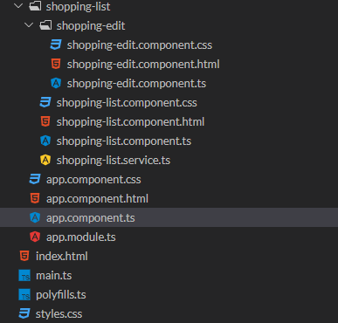

**Using components:**

Now I will start using them in the app.component.html file.

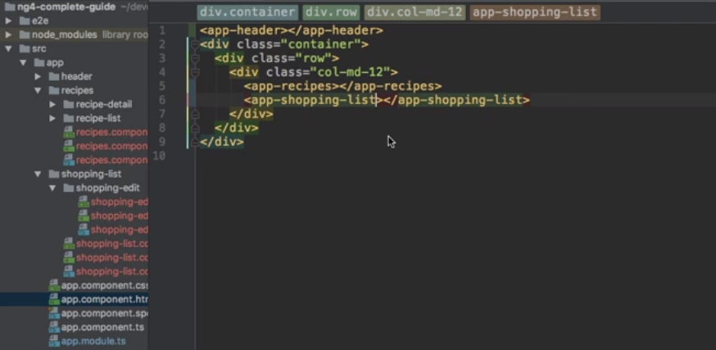

**Output:**

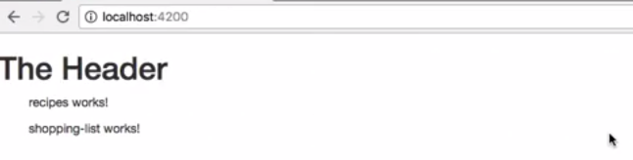

Here these strings are default given by CLI.

**Adding a navigation bar:**

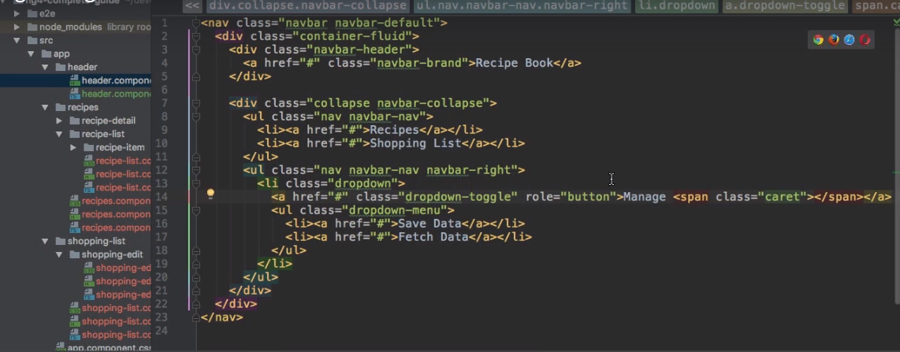

**Output:**

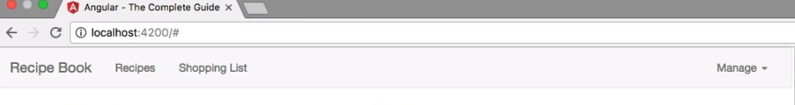

**Creating a recipe Model:**

A model is a simply a type script file designed to access from any component ,this is used to represent how the recipes should look like.

For that right click on the recipes folder and click on create a file.

Give the name as recipe.model.ts and click ok.

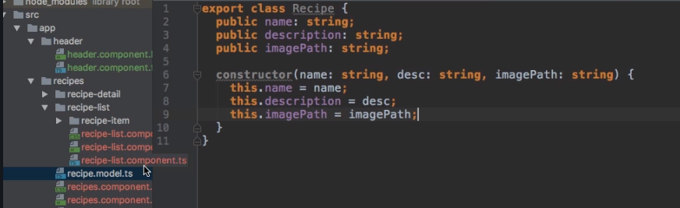

**Adding the content to recipe components:**

**Recipe-list. Component.ts file:**

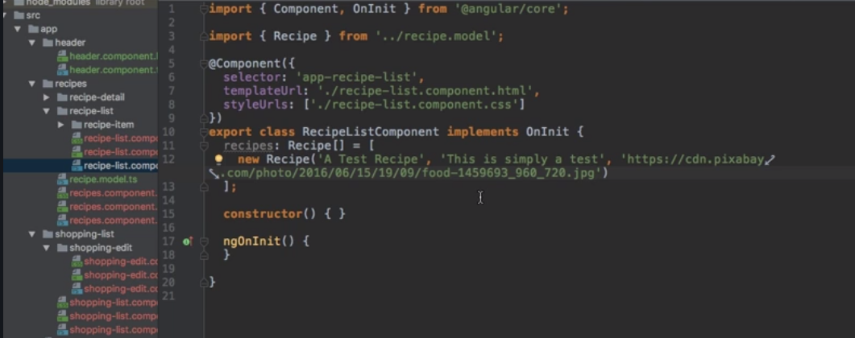

**Recipe.component.html file:**

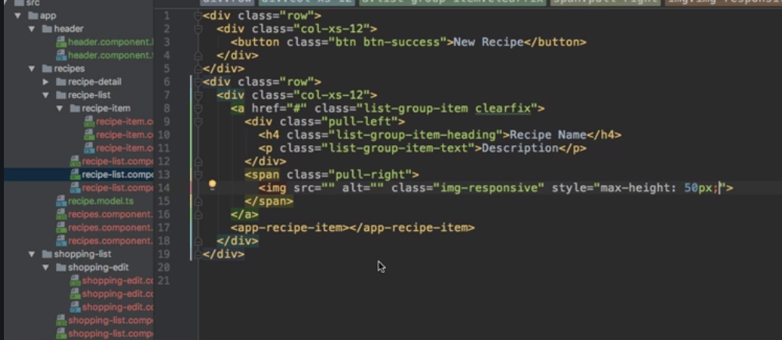

**Outputting the list of recipes with ngFor :**

**Recipe-list.component.html file:**

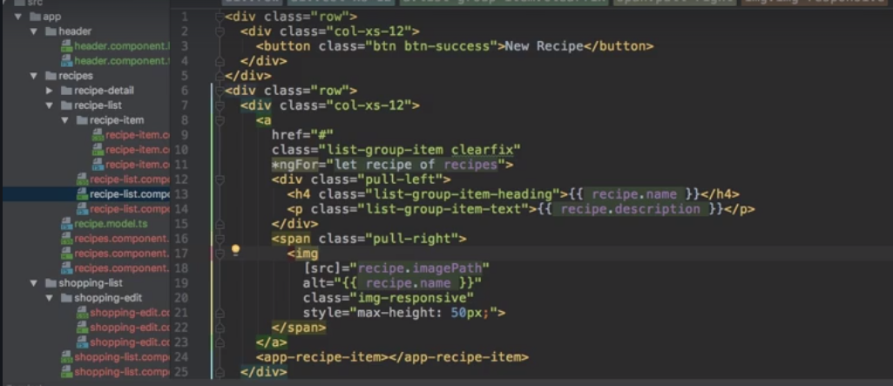

**Output:**

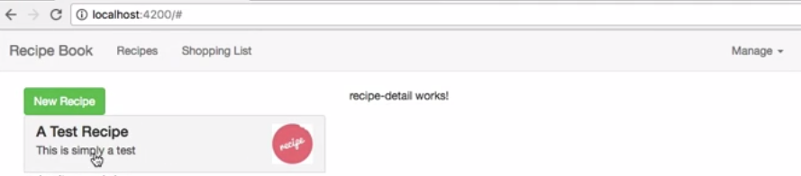

**Displaying the recipe details:**

**Recipe-detail.component.html file:**

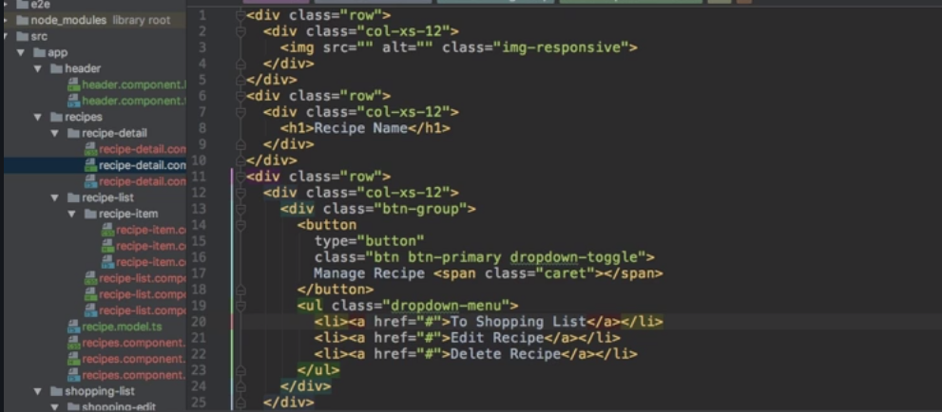

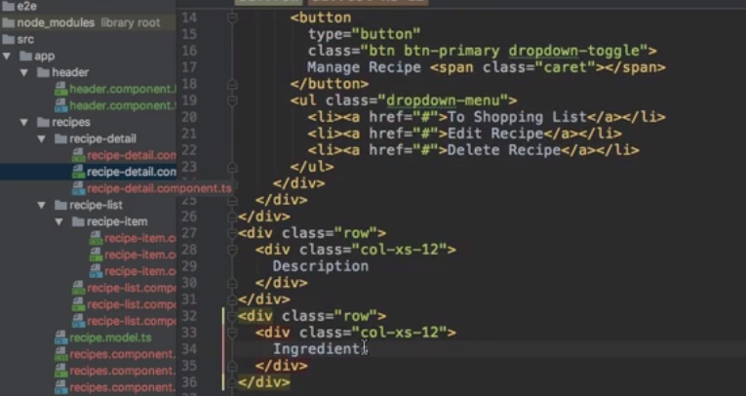

**Output:**

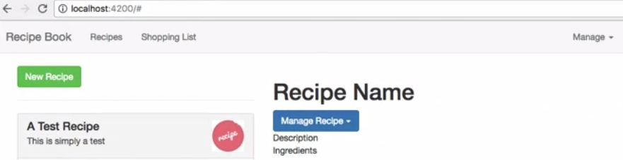

**Working on the shopping-list component:**

**Shopping-list.component.html file:**

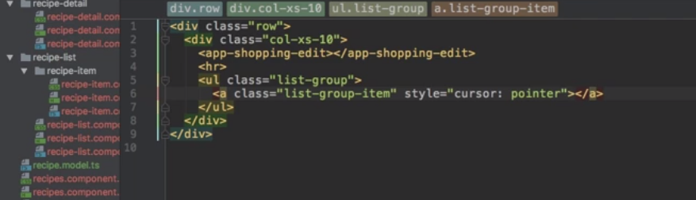

**Shopping-list.component.ts file**

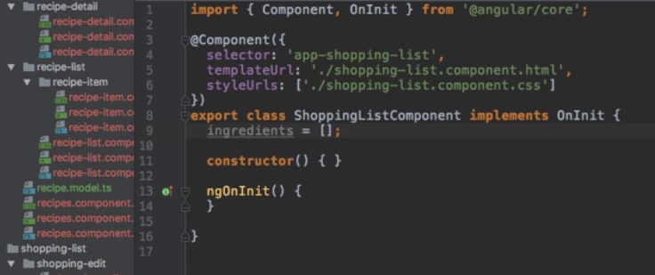

**Creating an ingredient model:**

For that right click on the app folder, now click “add new folder” and click ok.

Give the name as “shared”. This file is shared among all the components.

Now right click on the shared folder, select “ add new file” press ok.

Give the name as “ingredient.model.ts”.

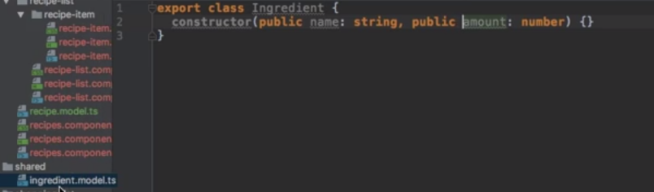

**Creating and outputting the shopping-list:**

**Shopping-list.component.ts file:**

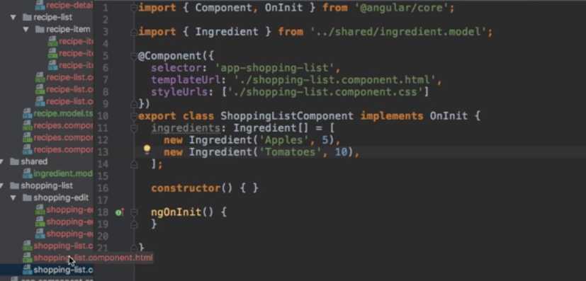

**Shopping-list.component.html file:**

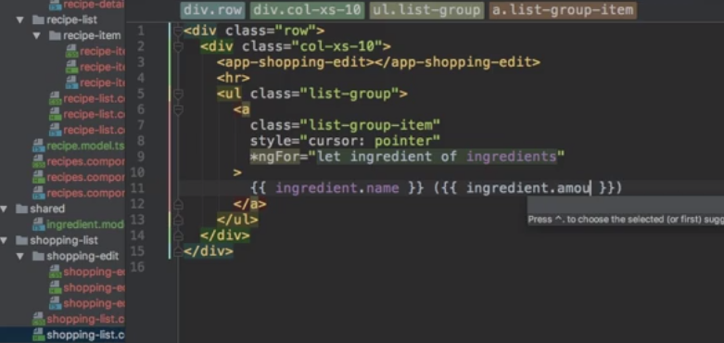

**Output:**

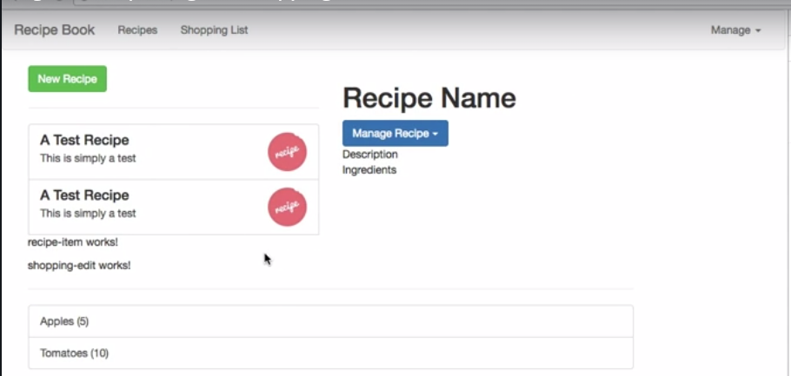

**Adding a shopping-list edit section:**

**Shopping-list edit.component.html:**

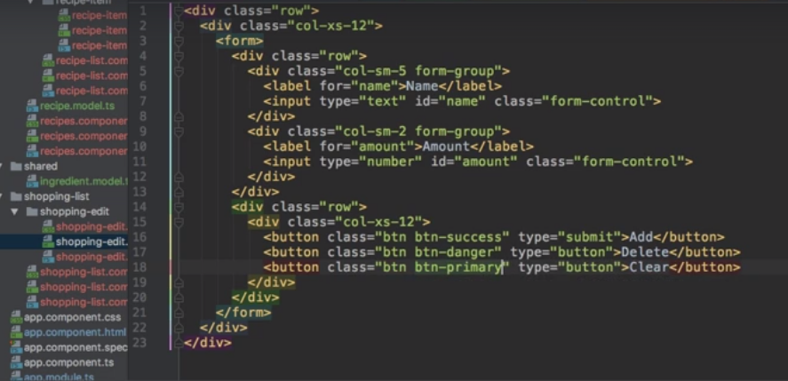

**Output:**

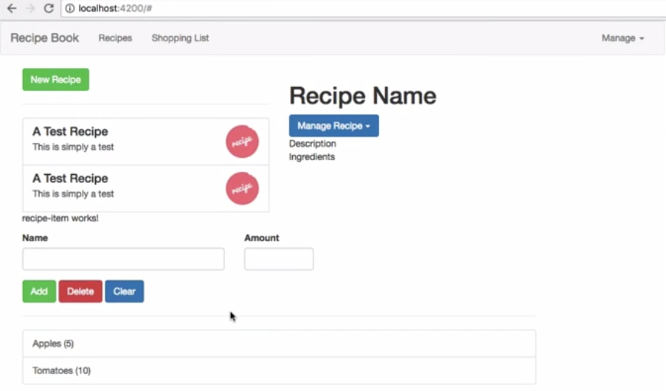

**Debugging:**

**Understanding the angular error messages:**

Let us consider the following example.

**App.component.html file:**

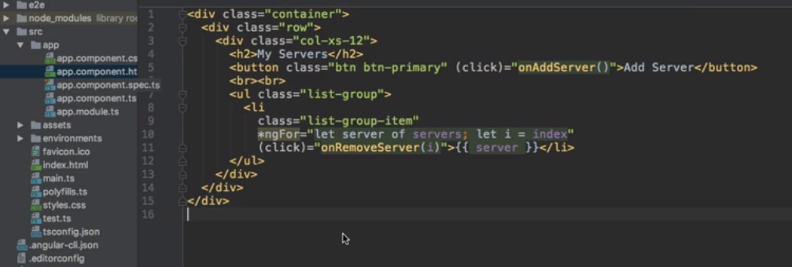

**App.component.ts file:**

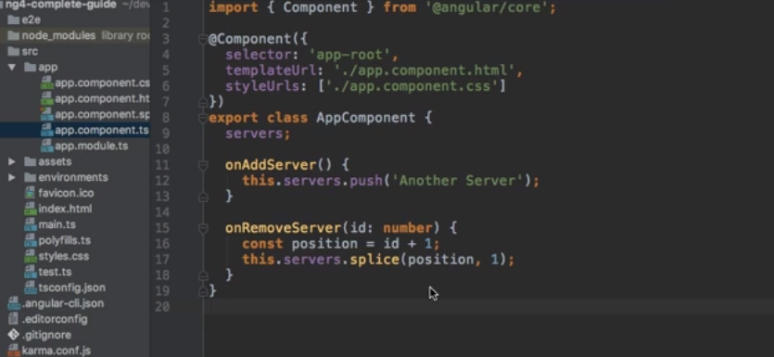

By running the above codes we will get the following errors.

To view the errors open console window in browser.

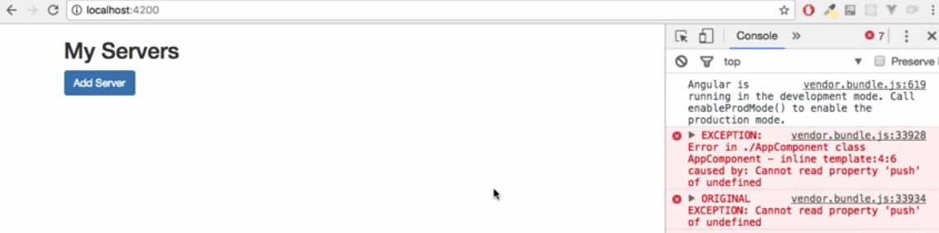

We are getting above errors because push is not correctly defined. we see that there is only one place where we call push on onAddServer method which makes sense because this is the method which gets triggered once we click the button. Here push operation is done on servers property. Servers is declared but not properly defined whether it is string or array etc.

If we declare servers as array as follows below action will happen.

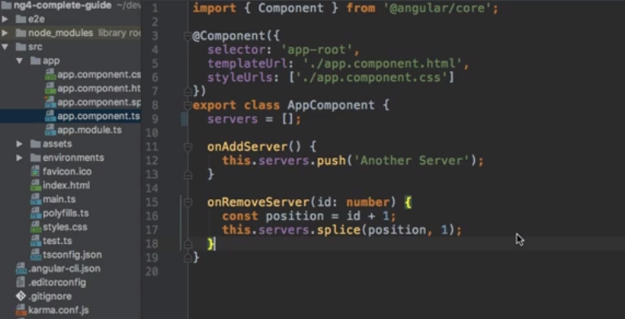

After running above the output is,

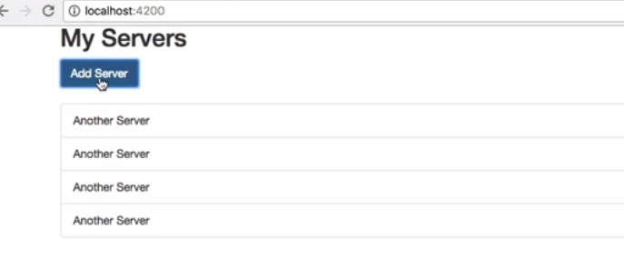

**63.Using augury to dive into angular apps:**

Here angular augury is chrome extension. we can add it to chrome by

Open Google chrome and search for augury.

You will get the following website.

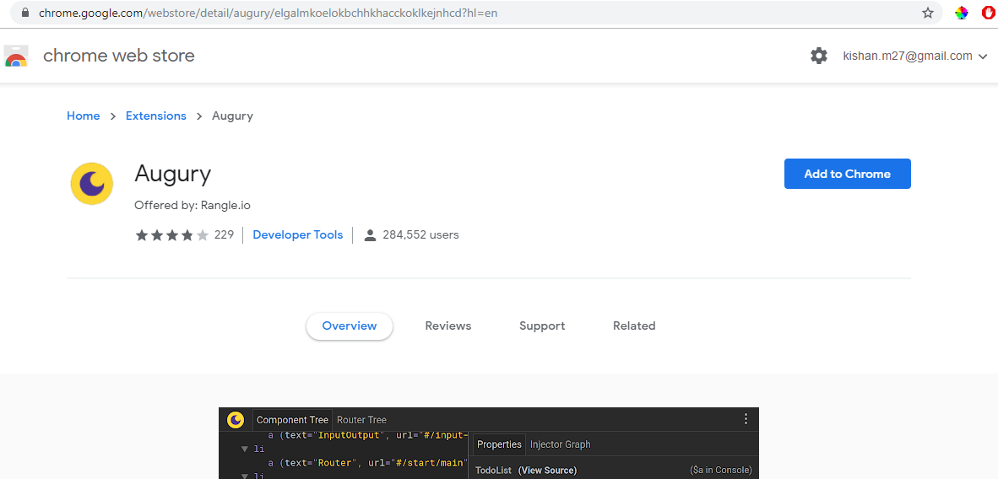

Now click on “add to chrome”.

Now it is successfully added.

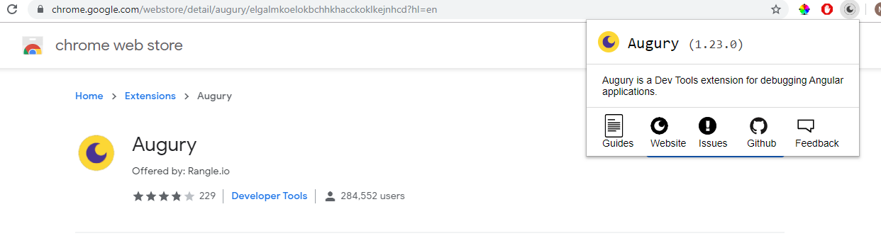

Now run your app and open augury.

Augury is a nice little tool which allows you to analyze your Angular application. Here we can sell all our components which have been used and on this you can have a look at the injector graph. You can check your NgModules like the app module, what it imports, what it declares,what it offers So this is a nice little tool to understand your app at runtime

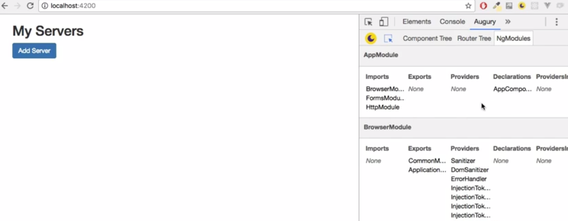

**Components and data binding in deep dive:**

**Splitting apps into components:**

Here there is a big amount of code in app.component.html file.

It is not a good idea that having entire code at one place .

We have split into some components. Those components can be reusable.

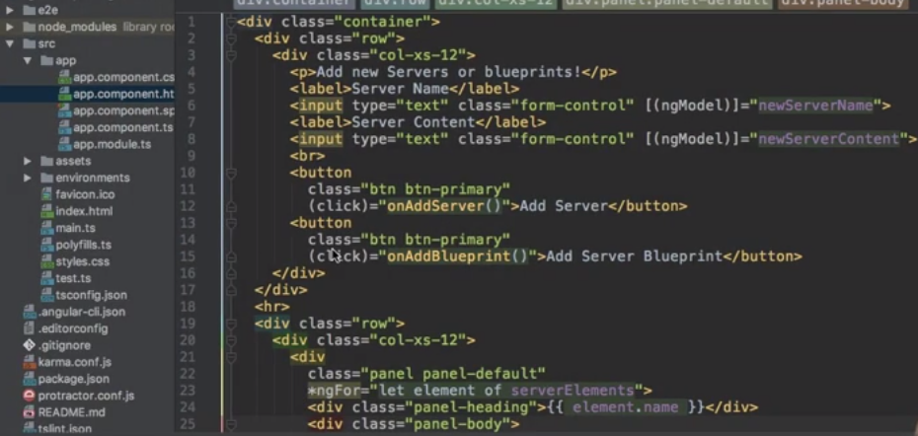

Now create two new components as 1.cockpit 2.server-element.

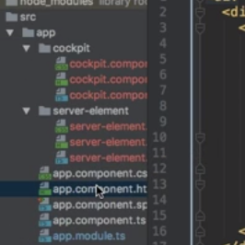

Now move the first row class to cockpit.component.html

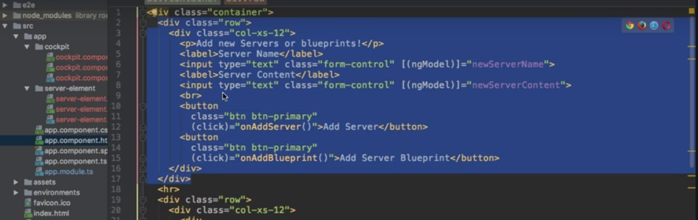

Now we have to move the methods which are calling here to cockpt.component.ts

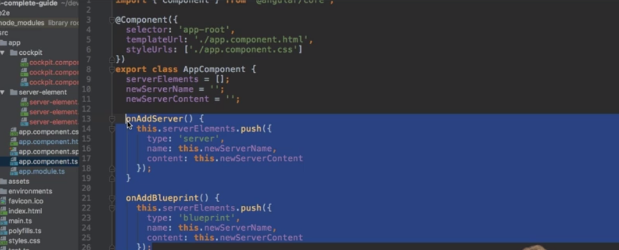

Now move the server elements to the cockpit.components.ts

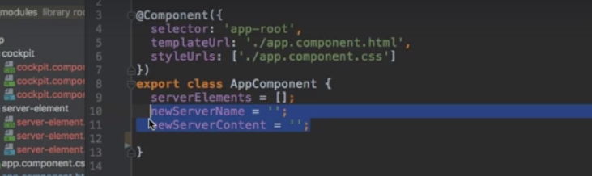

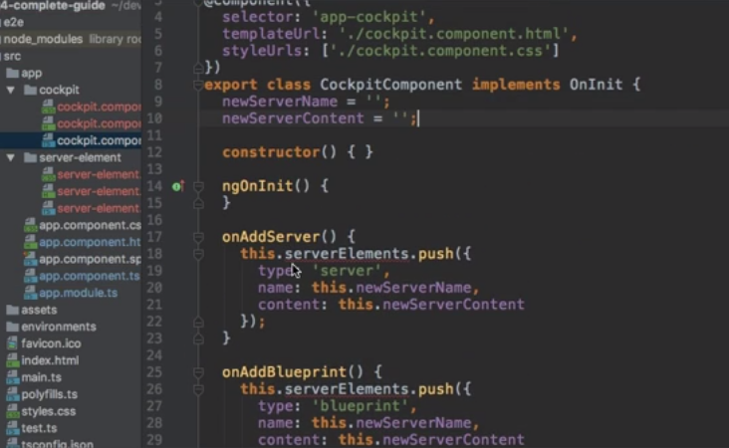

Now go to app.component.html file and move the single server code into server.element.html

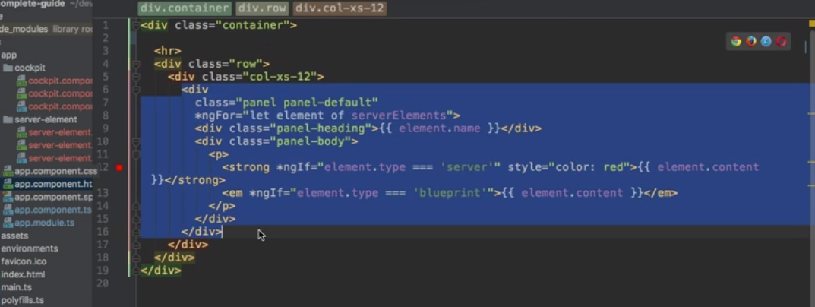

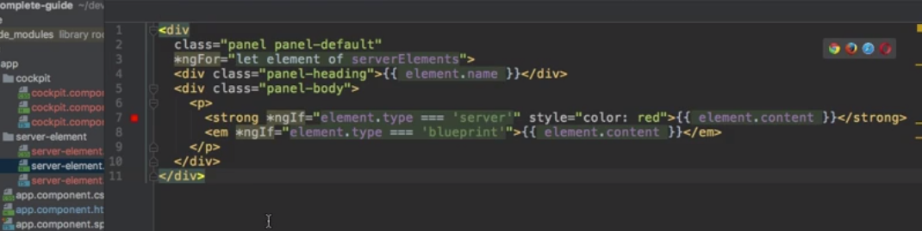

Now add the <app-cockpit></app-cockpit>, <app-server-element></app-server-element>

In the following way in app.component.html.

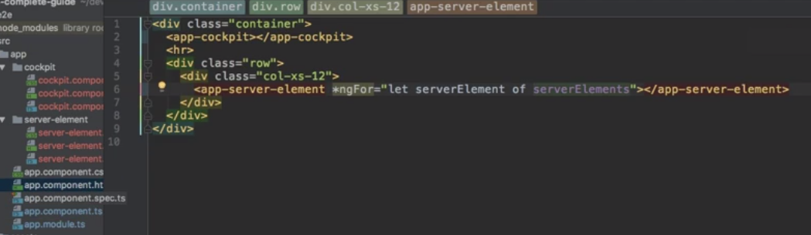

**Property and event binding:**

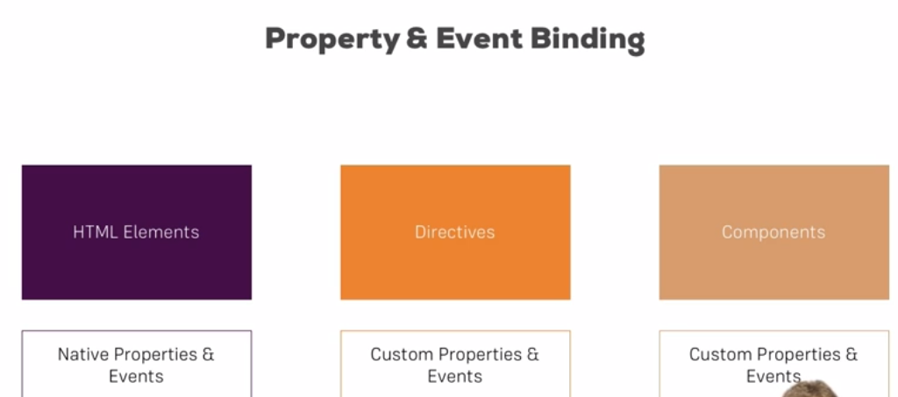

Data Binding is applicable to html elements ,directives and components.

**Binding to custom properties:**

**Server-element. Component.ts file:**

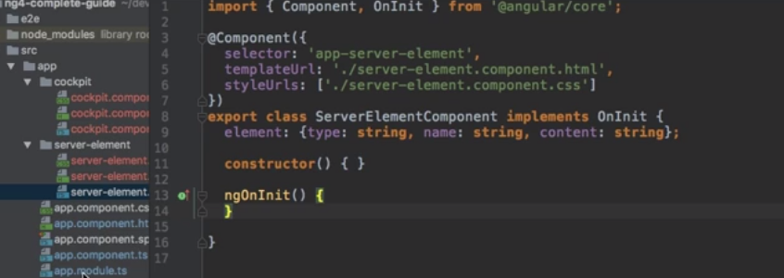

**app.component.ts file:**

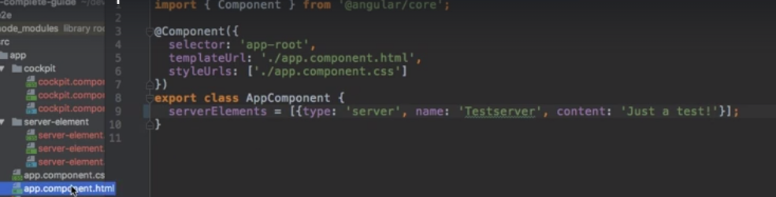

Now if we want to access this property from our parent component i.e. app.component.html file In this case this “element” cannot be accessed in our app-component.html file because by default , all the properties of a particular component are accessible inside that component only . In order to bind this property from outside , we need to add a Decorator i.e. **@Input** in the server-element.component.ts file

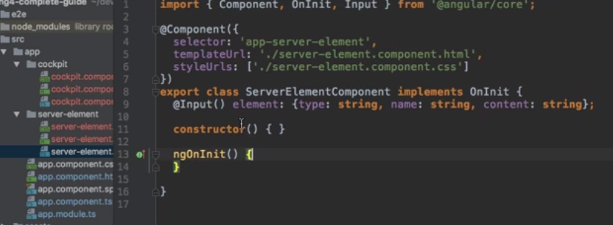

Now we are successfully exposing the element property.

**App.component.html file:**

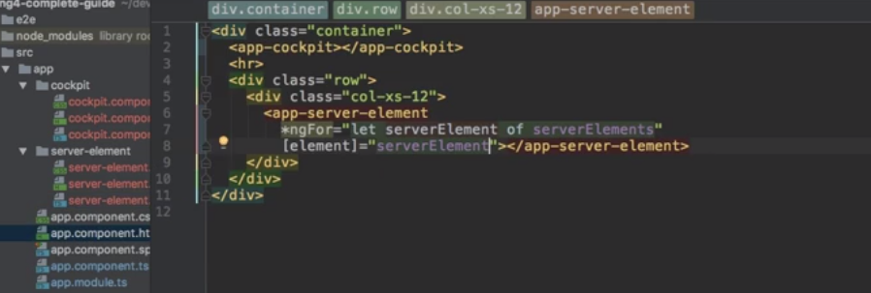

**Output:**

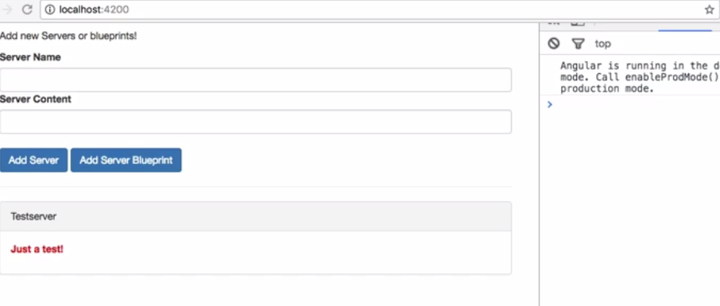

**64. Module introduction:**

**155. Adding Routing:**

**156.Setting Up Routes.**

|  |
| --- |
| import { NgModule } from '@angular/core';  import { RouterModule, Routes } from '@angular/router';  import { CreateEmployeeComponent } from './hrms/employees/create-employee/create-employee.component';  import { ViewEmployeesComponent } from './hrms/employees/view-employees/view-employees.component';  const routes: Routes = [    { path:'',redirectTo:'/view-employees',pathMatch: 'full'},    {path:'create-employee',component: CreateEmployeeComponent},    {path: 'view-employees',component: ViewEmployeesComponent}  ];  @NgModule({    imports: [RouterModule.forRoot(routes)],    exports: [RouterModule]  })  export class AppRoutingModule { } |

**157. Adding navigation to the App.**

|  |
| --- |
| <li class="nav-item dropdown">                      <a class="nav-link dropdown-toggle" href="#" data-toggle="dropdown">Employees</a>                      <div class="dropdown-menu">                          <a class="dropdown-item" routerLink="/view-employees">View Employees</a>                          <a class="dropdown-item" routerLink="/edit-employee">Edit Employee</a>                          <a class="dropdown-item" routerLink="/create-employee">Create Employee</a>                      </div>   </li> |

**158. Marking active Routes**

|  |
| --- |
| <li routerLinkActive="active" class="nav-item dropdown"></li> |

**159. Fixing Page Reload Issues.**

**182 Forms:**

**183**

**184 Templates Driven and Reactive Approch**

**192 Using the Form State.**

By using dirty, valid and touched.

[disabled]="!form.valid"

[disabled] =”!form.dirty”

**193. Outputting validation error messages:**

It consist of touched, dirty and invalid and #f=ngModel ,

By using local reference id binding with ngModel we can validate the form.

*ngIf = “!email.valid && email.touched”

**194. Set Default with ngModel property binding:**

WE NEED TO WORK ON THIS.

**195. Using ngModel with Two Way Binding:**

No binding : just tell angular that an input is a control.

One way binding: to give tht control a default value.

Two way binding: instantly output it whatever you want to do with that value.

Every key press value is submitted to end from html to typescript.

**196. Grouping form controls:**

**Add a local reference create employee data like below, so all the elements which are in these of the ngModel group validated together**

|  |
| --- |
| <div class="form-group" ngModelGroup="createEmployeeData" #createEmployeeData="ngModelGroup">              <p class="help-block" *ngIf="!createEmployeeData.valid && createEmployeeData.touched ">please enter a valid create employee Form Data </p> |
| onSubmit(){      console.log(this.createEmployeeForm);      this.employee.firstName = this.createEmployeeForm.value.createEmployeeData.firstName; |

**197.handling radio buttons**

**198.setting and patching form values**

**199 using form data**

**200 resetting forms.**

**240. Introduction to Pipes.**

Used pipes to **transform** the data into template.

241.Using Pipes?

LowerCasePipe

UpperCasePipe

CurrencyPipe

DatePipe

DecimalPipe

JsonPipe

PercentPipe

SlicePipe

AsyncPipe

242. Parameterizing pipes:

date: ‘fullDate’

243. Chaining multiple pipes.

date: ‘fullDate’ | uppercase

254. Custom pipes:

If we want to build custom pipes what are the steps we can follow.

Write a typescript class and implements the PipeTransform and override the transform method, and add the class name in the declarations array of App.module.ts

**250 A New IDE:**

Microsoft visual studio code

**251 Http & Backend interaction:**

**252 How does Angular interacts with Backbends:**

**253 The Anatomy of a Http Request:**

**254 Oracle Database Setup:**

**255 Sending Post Request:**

**256 Getting the data:**

**257 Using RxJS operators to transform Response Data:**

**258 Using types with Http Client.**

**259 outputting post:**

**260 Showing a loading indicator:**

**261.using a service for HTTP requests.**

**262. services and components working together?**

**263. Handling errors?**

**How to handle service errors in Angular?**

**Default way.**

**Custom way.**

**265. Using subjects for errors handling?**